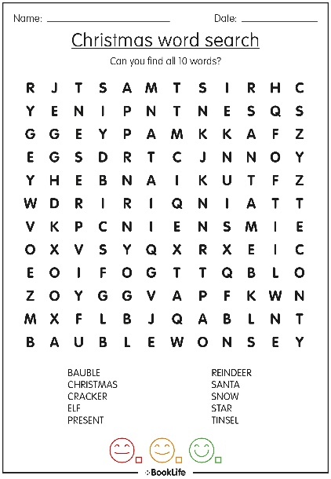**Building a WordSearch – project plan**

1. Build page in HTML.
   1. Title
   2. List of words to be found
   3. *Collapsible hint? Or Timer functionality?*
2. Build wordsearch grid in SCSS.
   1. E.g. 12 columns x 13 rows
3. Style the page.
   1. Media queries for tablet or desktop
   2. For mobile the list of words to be found is on the left?
4. TypeScript:
5. Define array of words to find.
6. Place the array of words in the grid.
7. Generate random letters.
8. Place the random letters in the grid.
9. User has to click every letter? Can they click and drag?
   1. The basic difference between a click and a drag event is mouse movement. The mouse event that differentiates a click and drag event is the “mouse move” event. In a “click” event, there is no “mouse move” event.
   2. <https://www.geeksforgeeks.org/how-to-differentiate-mouse-click-and-drag-event-using-javascript/>
10. Found words in the wordsearch are changed a different colour.
11. Found words in the list are also changed to a different colour / are strikethrough-ed
12. Hooray when they’ve finished the wordsearch (confetti)
13. Option to progress to the next level and take a more difficult wordsearch? Or have a drop down with Easy, Medium, and Hard wordsearches?